October and November Newsletter 2023
Adopted: Stoneharbor Blonde, Blowing Strong and Classical Fashion

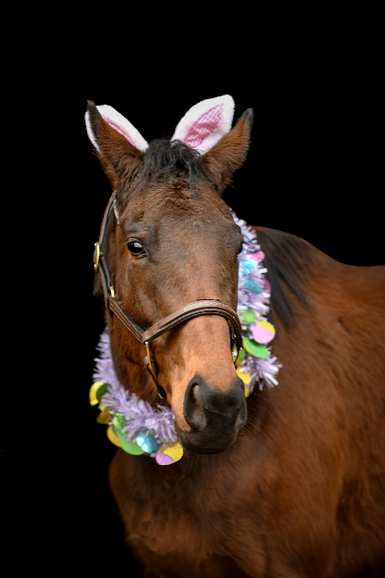
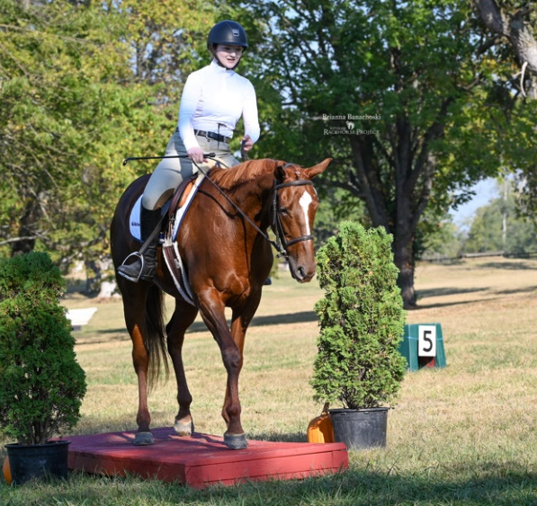

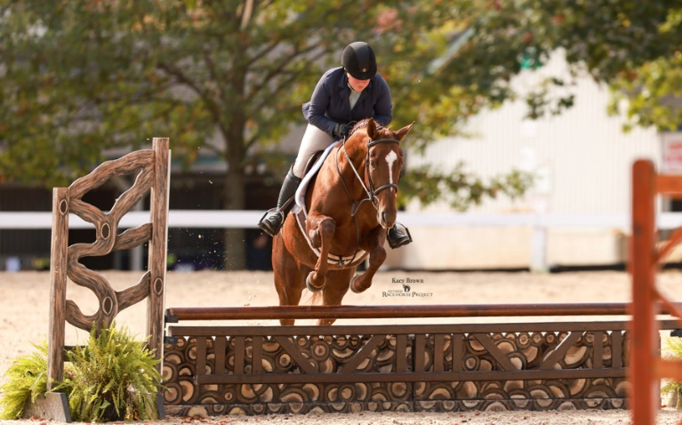
Stoneharbor Blonde attended the Thoroughbred Makeover in Kentucky and was a good girl. She was adopted shortly after returning home. Blowing Strong and Classical Fashion were adopted together!

New Arrivals: Introducing Gentle Ride and Causaway!
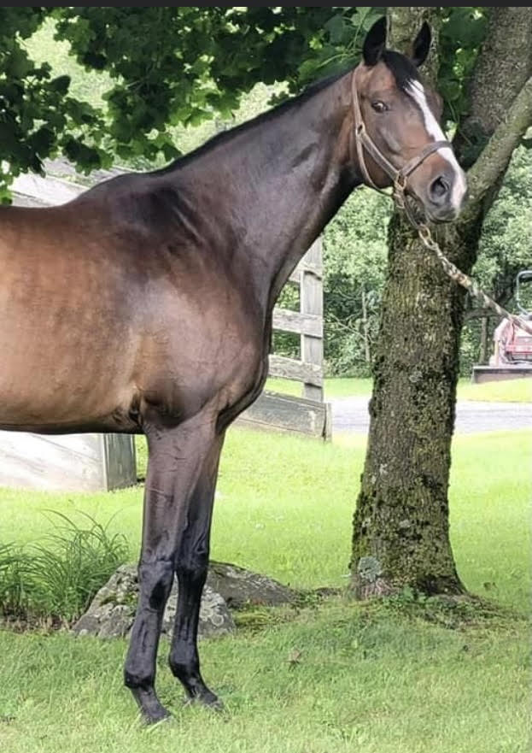

Contact Us:
(607) 882-1353
sctottbs@gmail.com
Second Chance Thoroughbreds, Inc. | Known for their athleticism, heart and desire to please – ride an OTTB today!

